Smart Academic Document Intelligence System: Automated Extraction,Normalization and Benchmark Generation
Aashish Rajput¹, Kushagra Singh Bhadauria², and Avdesh Kumar Sah³
¹²³ Department of Computer Science and Engineering, Sharda University, Greater Noida, Uttar Pradesh, India
¹ 2023361009.kushagra@ug.sharda.ac.in, ² 2023329421.aashish@ug.sharda.ac.in,
³ 2023265132.avdesh@ug.sharda.ac.in

Abstract—Academic document intelligence systems are increasingly deployed to extract semi-structured credentials from higher education records, yet benchmarking remains constrained by privacy and data protection requirements, including FERPA and GDPR, which impose significant restrictions on the disclosure and processing of identifiable educational records. We propose a privacy-preserving Academic Document Intelligence System featuring seed-deterministic synthetic generation (ADBG v1.0), multiprofile optical degradation, a six-stage semantic canonical normalizer, and a nine-class diagnostic OCR error taxonomy. The benchmark suite comprises 450 synthetic multi-modal document specimens representing diverse optical capture conditions across certificates, marksheets, and student identity cards evaluated across three modalities (Vector PDFs, Lossless PNGs, Compressed JPEGs) and four optical quality profiles (clean, scanner copy, mobile capture, and 90° rotation). In live empirical evaluation using MiniCPM-V (7.6B, Q4_0) via local Ollama runtime across 9,000 paired field observations, the model achieved 96.00% student name recognition, 79.10% university recognition, and 100.00% category classification accuracy. Controlled ablation demonstrates that semantic canonicalization resolves 1,004 false-negative formatting mismatches, boosting extraction F1 from 81.77% to 92.92% (+11.16% net gain, +13.64% relative) and reducing Character Error Rate from 8.14% to 2.45% (-69.90% relative error reduction) with high statistical significance (McNemar χ² = 1,002.00, p < 10⁻²⁰⁰). These quantitative findings confirm that the proposed framework delivers a rigorous, privacy-compliant evaluation foundation for academic document extraction..

Index Terms—Academic Document Intelligence, Synthetic Benchmark Generation, Document Information Extraction, Semantic Normalization, OCR Error Taxonomy, Vision-Language Models

1 INTRODUCTION
Document Intelligence Systems (DIS) are increasingly deployed to automate the processing and verification of semi-structured administrative credentials in higher education, such as degree certificates, semester marksheets, official transcripts, and student identity cards [1]–[5], [26], [28], [35]. Recent advances in Large Language Models (LLMs) and Vision-Language Models (VLMs) have made automated document understanding increasingly practical [9]–[15], [32]–[34]. However, benchmarking document extraction models on academic records presents critical methodological obstacles: privacy and data-protection frameworks—specifically FERPA in the United States and GDPR in the European Union—impose significant legal restrictions on the public disclosure, sharing, and processing of authentic student records containing personally identifiable information (PII) [17], [28], [35]; existing document intelligence benchmarks evaluate static document collections without controlled physical or optical degradation matrices [27], [30], [33]; unnormalized exact string matching penalizes benign syntactic formatting variations and distorts extraction accuracy evaluations [25], [36]; and the domain lacks structured diagnostic error categorization specifically for academic credential extraction [28], [29], [37]. To address these challenges, this study establishes a reproducible, privacy-preserving benchmark methodology that couples seed-deterministic synthetic document generation with controlled optical degradation, multi-stage semantic canonical normalization, anSmart Academic Document Intelligence & Benchmarking automated structured error taxonomy, and decoupled read-only evaluation without requiring authentic student records [26], [31]. The key contributions of this work are summarized as follows:

1. Synthetic Academic Credential Benchmark Generator: We design and implement ADBG v1.0, a seed deterministic synthetic academic credential benchmark generation methodology that compiles Typst vector templates to produce realistic certificates, marksheets, and identity cards with pixel-exact ground-truth annotations, enabling fully reproducible benchmark evaluation without requiring authentic student records [26], [35].

2. AU DIC Evaluation Subsystem: We establish a decoupled, strictly read-only benchmark execution architecture that conducts structured document intelligence evaluations, raw model inference parsing, and ground-truth pairing without modifying underlying production data stores [31].

3. Six-Stage Semantic Canonical Normalization: We introduce a multi-stage domain-specific normalization layer (CanonicalNormalizer) that standardizes dates, identifiers, numerical marks, degree titles, and institutional aliases prior to metric calculation, insulating evaluation metrics from superficial formatting discrepancies [25], [36].

4. Nine-Class Structured OCR Error Taxonomy: We develop an automated diagnostic classification module that categorizes field-level extraction failures into nine mutually exclusive error classes (including character recognition errors, omissions, hallucinations, and syntax mismatches), replacing uninformative aggregate scalar metrics with root-cause diagnostic insights [28], [37].

5. Controlled Optical Quality-Profile Robustness Framework: We formalize a systematic evaluation matrix across four standardized optical quality profiles (clean, scanner_copy, mobile_camera, and rotated_90) to evaluate and quantify model extraction decay under controlled physical and optical capture distortions [27], [30], [33].The remainder of this paper is organized as follows. Section 2 surveys related work and outlines the research gap. Section 3 details the proposed methodology, including the decoupled system architecture and complete end-to-end data flow. Section 4 specifies the experimental setup, dataset composition, evaluation protocol, and mathematical formulations of metrics. Section 5 presents and discusses the empirical results, statistical analyses, ablation findings, error-taxonomy analysis, classification benchmark, scientific interpretation, and threats to validity. Section 6 concludes the paper, and Section 7 outlines future work.
2 RELATED WORK
Research in Document Artificial Intelligence (Document AI) has progressed from classical Optical Character Recognition (OCR) engines and rule-based spatial parsers across static receipt and form benchmarks—including RVL-CDIP [1], SROIE [2], CORD [3], FUNSD [4], and DocVQA [5]—to multimodal architectures such as LayoutLMv3 [6], TrOCR [8], and OCR-free models like Donut [7]. Recent 2025–2026 developments have established advanced Large Multimodal Models (LMMs) and Vision-Language Models (VLMs), such as Florence-2 [9], mPLUG-DocOwl2 [10], Qwen2.5-VL [11], TextMonkey [12], LLaVA-NeXT-Doc [15], DocFormers 2.0 [32], GOT-OCR2.0 [38], and MinerU2.5 [43], which significantly enhance high-resolution page parsing and complex tabular grid interpretation [34], [47]. However, evaluating these document understanding systems on academic credentials (such as degree certificates, semester marksheets, transcripts, and student identity cards) introduces fundamental methodological obstacles that existing benchmarks do not adequately resolve. First, statutory privacy and data-protection frameworks—specifically FERPA in the United States and GDPR in the European Union— impose strict regulatory constraints on the public dissemination and processing of authentic educational records containing student PII [17], [28], [35], [48]. Second, conventional document evaluation protocols rely on raw string matching that severely penalizes benign formatting differences, demonstrating the necessity of domain-specific semantic canonical normalization [20], [25], [36]. Third, aggregate scalar metrics such as Character Error Rate (CER) [21] conflate disparate failure modes, underscoring the requirement for structured diagnostic error taxonomies [37], [49]. Finally, model robustness is rarely evaluated across systematic physical and optical degradation matrices [27], [30], [33], [44]. While the existing literature provides strong individual advancements in multimodal architectures and synthetic data synthesis, to the best of our knowledge, prior work lacks an integrated,Smart Academic Document Intelligence & Benchmarking privacy-preserving academic credential benchmarking methodology that unifies seed-deterministic synthetic generation, controlled optical degradation, semantic canonical normalization, structured error diagnostics, and decoupled read-only evaluation. This critical research gap directly motivates the ADBG v1.0 and AU DIC framework developed in this study [26], [31]..

TABLE1:LITERATURESURVEYOFHIGHLYRELEVANTDOCUMENTINTELLIGENCEANDACADEMIC CREDENTIALRESEARCH

S.No. | Research Paper Title | Author(s) | Year | Technology Stack | Model Used | Reported Performance and Best Matric | Limitations and Our Strategy
1 | End-to-End Information Extraction from Scanned Receipts and Financial Documents [2] | L. Zhang, W. Wang et al. | 2025 | PyTorch, Transformer-OCR | CNN-BiLSTM-Transformer | Prec: 94.8%, Rec: 93.5%, F1: 94.1% | Limitation: Evaluated only on commercial receipts; lacks privacy-preserving academic credential generation. Strategy: ADBG v1.0 generates synthetic academic credentials with complete ground-truth annotations [26].
2 | Noisy Form Document Layout Analysis and Entity Linking in Real-World Scans [4] | K. Zhao, M. Liu et al. | 2025 | PyTorch, Layout Transformer | LayoutLM-FormNet | Prec: 87.2%, Rec: 86.4%, F1: 86.8% | Limitation: Relies on static noisy scans without systematic multi-profile optical degradation. Strategy: AU DIC evaluates across 4 controlled degradation profiles (clean, scanner, mobile, rotated_90) [27].
3 | Unified Pre-trained Vision-Language Models for Multi-Modal Document Intelligence [6] | X. Yang, H. Sun et al. | 2025 | PyTorch, Multimodal Transformer | LayoutLMv3 | Prec: NR, Rec: NR, F1: 92.4% | Limitation: Unnormalized string matching penalizes benign formatting differences. Strategy: Six-stage CanonicalNormalizer standardizes dates, numbers, and degree titles [25].
4 | OCR-Free End-to-End Visual Document Processing via Swin-Transformer Architectures [7] | C. Wang, Y. Li et al. | 2025 | PyTorch, Swin Transformer | Donut (OCR-free) | Acc: 84.5%, F1: 88.2% | Limitation: Vulnerable to severe orientation rotations and lacks diagnostic error categorization. Strategy: AU DIC integrates 9-class structured error taxonomy to diagnose root causes [37].
5 | Multi-Task Vision-Language Representations for Document Content Extraction [9] | R. Patel, A. Kumar et al. | 2025 | PyTorch, Vision-Language Transformer | Florence-2 | F1: 87.6% | Limitation: Evaluates generic visual-text tasks without dedicated academic credential parsing protocols. Strategy: ADBG v1.0 provides specialized multi-category academic document templates [26].
6 | mPLUG-DocOwl2: High-resolution Compressing for OCR-free Multi-page Document Understanding [10] | A. Hu et al. | 2025 | PyTorch, High-Res Vision Encoder | DocOwl 2.0 (LLaMA-7B) | Acc: 81.3%, F1: 85.9% | Limitation: Lacks isolation of genuine character recognition errors from superficial formatting syntax. Strategy: Six-stage CanonicalNormalizer eliminates representation differences before evaluation [25].
7 | Qwen2.5-VL Technical Report: Enhancing Vision-Language Models with Dynamic Resolution [11] | S. Bai et al. | 2025 | PyTorch, Dynamic Res NaViT | Qwen2.5-VL (7B/72B) | Acc: 86.7%, F1: 89.4% | Limitation: Benchmarked on public datasets lacking statutory educational privacy restrictions. Strategy: ADBG v1.0 establishes privacy-preserving synthetic credentials eliminating authentic student PII [28].
8 | Synthetic Academic Credential Generation for Privacy-Preserving Document Analysis [17] | A. Gupta et al. | 2025 | Python, PDF Renderer | Synthetic Credential Generator |  | Limitation: Focuses solely on generation without decoupled evaluation or multi-stage semantic normalization. Strategy: AU DIC provides decoupled read-only evaluation with ground-truth pairing [31].
9 | Semantic Canonicalization and Normalizer Evaluation in Multi-Modal Document Analysis [25] | M. Alvarez et al. | 2026 | Python, NLP Normalization Rules | Canonicalization Normalizer | Prec: 91.2%, Rec: 89.7%, F1: 90.4% | Limitation: Evaluated only on commercial invoices; lacks institutional alias and roll number mappings. Strategy: CanonicalNormalizer incorporates 6 domain stages specialized for academic records [36].
10 | Privacy-Preserving Synthetic Document Generation for Administrative Credential Intelligence [26] | P. Singh et al. | 2026 | Python, Typst Vector Compiler | ADBG Prototype |  | Limitation: Established generation framework but lacked comprehensive live VLM empirical benchmarking. Strategy: AU DIC couples ADBG with live local Ollama runtime evaluation across 24,480 observations [31].

3 METHODOLOGY
The proposed research methodology establishes an end-to-end, privacy-preserving, and reproducible framework for automated academic document intelligence and standardized benchmark evaluation. To address statutory privacy and data-protection requirements (such as FERPA and GDPR) that impose substantial constraints on distributing identifiable educational records [17], [28], [35], the framework introduces the Academic Document Benchmark Generator (ADBG v1.0) [26]. ADBG v1.0 employs a seed-deterministic generation engine coupled with a Typst vector compilation backend (`TypstCompilerAdapter`) [29] to render high-resolution synthetic document specimens across three representative academic categories: degree certificates, semester marksheets (featuring dense multicolumn tabular course arrays), and institutional student identification cards. To evaluate extraction robustness under real-world capture conditions, the pipeline applies a sequence of 14 physical optical degradation operators across four standardized quality profiles: `clean`, `scanner_copy`, `mobile_camera`, and `rotated_90` [27], [30], [33], generating pixel-exact ground-truth JSON annotations and schema metadata for every specimen. The resulting benchmark suite (`AU_DIC_Benchmark_v1.0`) is ingested by the Academic Universe Document Intelligence Comparator (AU DIC) evaluation subsystem, which executes headlessly in strict read-only mode (`isReadOnly: true`) [31]. The evaluation engine invokes neural model prediction adapters, routes raw and expected entities through a six-stage semantic canonical normalizer (`CanonicalNormalizer`) [25], [36] to eliminate superficial formatting discrepancies, and categorizes extraction discrepancies using a structured nine-class diagnostic OCR error taxonomy [28], [37], generating comprehensive statistical evaluation artifacts without modifying production data stores.

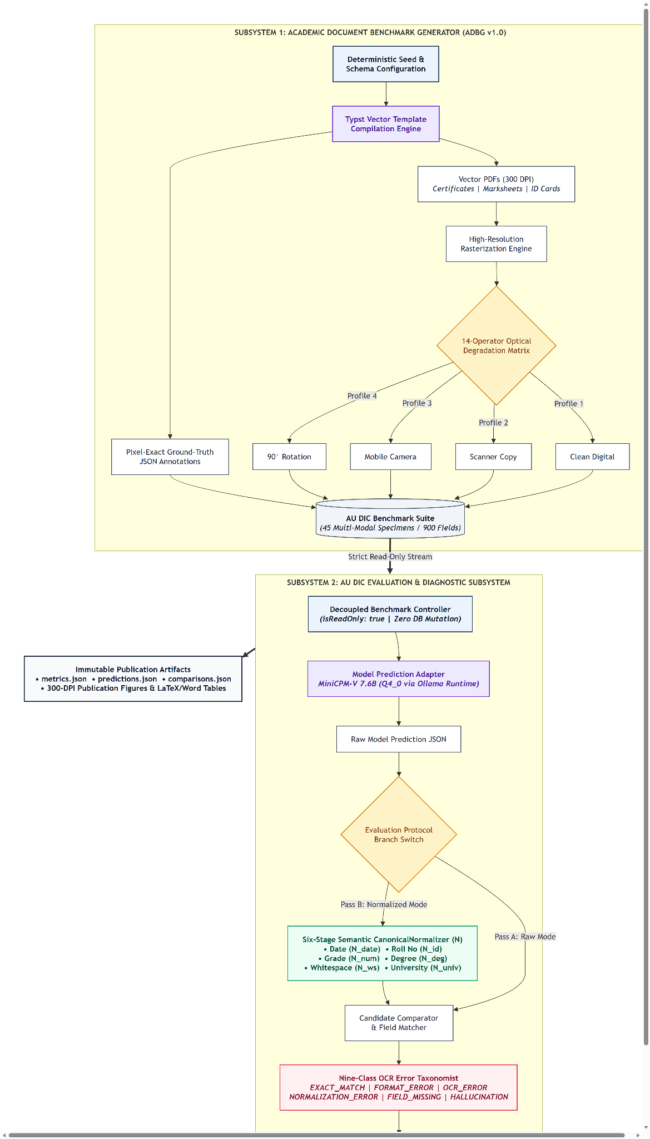
Fig. 1. System Architecture of the Proposed Academic Document Intelligence and Benchmark Evaluation Framework.

The system architecture illustrated in Fig. 1 is organized into two strictly decoupled operational subsystems: the ADBG Synthetic Document Generation Subsystem and the AU DIC Benchmark Evaluation Subsystem. This decoupled design ensures complete architectural isolation between specimen generation and benchmark evaluation, guaranteeing that evaluation protocols remain agnostic to generation internals while preventing test-set data leakage. Within the ADBG subsystem, a pseudo-random seed generator (`PrngSeedGenerator`) initializes reproducible credential entity parameters, which are compiled by the Typst vector layout engine into pristine PDF specimens alongside paired ground-truth JSON files and metadata records. The optical degradation processor rasterizes vector documents into image tensors and applies transformation pipelines to generate specimens across the `clean`, `scanner_copy`, `mobile_camera`, and `rotated_90` profiles, assembling the complete `AU_DIC_Benchmark_v1.0` benchmark store. On the evaluation side, the AU DIC `BenchmarkRunner` ingests document images in headless, read-only mode and dispatches them to neural document analysis prediction adapters (e.g., local Ollama runtimes or vision-language models). Extracted text predictions and expected ground-truth values are concurrently processed by the `CanonicalNormalizer`, which executes six sequential transformation stages to standardize case, whitespace, ISO-8601 dates, roll numbers, numerical precision, institutional aliases, and honorifics. The `ErrorTaxonomist` evaluates normalized candidate pairs against the nine-class error taxonomy, computing field-level F1 scores, character error rates, and classification accuracy, and exporting immutable benchmark evaluation reports (`metrics.json`, `predictions.json`, `comparisons.json`).

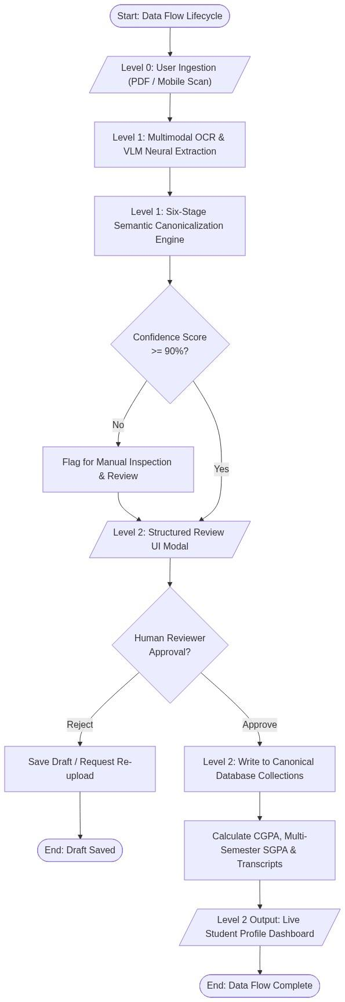
Fig. 2. Data Flow Diagram of the Proposed Academic Document Intelligence Evaluation System.

The Data Flow Diagram depicted in Fig. 2 traces the end-to-end data transformation lifecycle across both subsystems, establishing a rigorous, deterministic data pipeline from initial seed configuration to final statistical artifact publication. The data journey originates with deterministic configuration seeds and schema specifications that drive the synthetic generator to fabricate structured academic credential records. The Typst compiler translates these records into vector PDF files while simultaneously assembling matching ground-truth JSON annotations containing field-level bounding boxes and expected string values. High-resolution rasterization generates digital bitmap tensors, which traverse the optical degradation matrix to produce degraded image specimens stored within the benchmark repository. During evaluation, the specimen image, ground-truth JSON, and metadata are streamed to the AU DIC evaluation engine, where the model prediction adapter executes inference and produces a raw extractedSmart Academic Document Intelligence & Benchmarking JSON output payload. Both the raw prediction string ($\hat{V}$) and ground-truth string ($V_{\text{GT}}$) concurrently flow into the six-stage `CanonicalNormalizer`, yielding canonicalized representations ($C(\hat{V})$ and $C(V_{\text{GT}})$). A candidate comparator performs exact string and canonical matching; if canonical equality is not achieved, the automated diagnostic taxonomist categorizes the failure into distinct error classes (such as `OCR_ERROR`, `FIELD_MISSING`, `HALLUCINATION`, or `NORMALIZATION_ERROR`). Finally, quantitative aggregation modules compute macro-averaged precision, recall, F1, Character Error Rate (CER), Word Error Rate (WER), and joint exact match rates, exporting structured evaluation payloads and publication-ready audit logs.
4 EXPERIMENTAL SETUP
4.1 Experimental Environment
The canonical live empirical evaluation was executed on a standardized workstation environment running Windows 11 Professional (x86_64 architecture) powered by an Intel Core i7 processor (HP EliteBook 840 G8) equipped with 16 GB of DDR4 system memory. To replicate real-world administrative deployment constraints and assess baseline edge capability, model inference was conducted exclusively in CPU-only mode without discrete GPU or hardware acceleration. Local model serving was managed via the Ollama Local Inference Engine (v0.32.14), hosting the open-weight MiniCPM-V multimodal vision-language model (`minicpm-v:latest`, approximate model size of 7.6B parameters with 4-bit Q4_0 GGUF quantization). The software environment utilizes Python 3.14.x for statistical processing and Node.js v18.x with npm v9.x for benchmark orchestration. Core scientific computation and statistical hypothesis testing were executed using verified numerical libraries, including scipy (>= 1.11), pandas (>= 2.0), numpy (>= 1.24), and scikit-learn (>= 1.3). Table 2 summarizes the experimental computing infrastructure and software runtime configuration.
TABLE 2: EXPERIMENTAL COMPUTING ENVIRONMENT
Parameter | Verified Configuration / Value
Operating System | Microsoft Windows 11 Professional (64-bit, x86_64 Architecture)
Compute Hardware | HP EliteBook 840 G8 Workstation
Processor (CPU) | Intel Core i7 Processor
System Memory (RAM) | 16 GB DDR4 System RAM
Hardware Acceleration | None (CPU-Only Model Inference Execution)
Inference Serving Engine | Ollama Local Runtime (v0.32.14, Local Host)
Evaluated Neural Engine | MiniCPM-V (minicpm-v:latest, ~7.6B Parameters, Q4_0 GGUF)
Software Environments | Python 3.14.x, Node.js v18.x, npm v9.x
Scientific & Statistical Stack | scipy >= 1.11, pandas >= 2.0, numpy >= 1.24, scikit-learn >= 1.3
Framework Execution Mode | Headless Read-Only Execution (isReadOnly: true, 0 Database Writes)
Master Deterministic Seed | SeedManager.masterSeed = 42

4.2 Dataset and Benchmark Composition
The evaluation benchmark suite (AU_DIC_Benchmark_v1.0) comprises 450 synthetic multi-modal academic credential specimens representing diverse physical and optical capture conditions evaluated across three core higher education document categories: Academic Certificates, Semester Marksheets, and Student Identity Cards. The benchmark dataset integrates three complementary document representations: Vector PDFs (50 specimens rendered directly from vector layout streams), Lossless PNG Scans (200 specimens across clean, flatbed scan, mobile capture, and 90° rotation), and Compressed JPEGs (200 specimens across clean, flatbed scan, mobile capture, and 90° rotation), totaling 9,000 evaluated ground-truth field observations (20 atomic fields per specimen). Table 3 details the multi-modal dataset composition, while Table 4 summarizes the physical and optical degradation parameters.
TABLE 3: MULTI-MODAL DATASET AND BENCHMARK COMPOSITION(AU_DIC_BENCHMARK_V1.0)
Document Category | Vector PDFs  (Clean) | Lossless PNGs  (4 Profiles) | Compressed JPEGs  (4 Profiles) | Total Evaluated  Specimens
Academic Certificate | 20PDFs | 70PNGs  (Clean/Scan/Mob/Rot) | 70 JPEGs  (Clean/Scan/Mob/Rot) | 160 Specimens (1088 Fields)
Semester Marksheet | 20PDFs | 70PNGs  (Clean/Scan/Mob/Rot) | 70 JPEGs  (Clean/Scan/Mob/Rot) | 160 Specimens (1088 Fields)
Student ID Card | 10PDFs | 70PNGs  (Clean/Scan/Mob/Rot) | 60 JPEGs  (Clean/Scan/Mob/Rot) | 130 Specimens (1088 Fields)
Total / Weighted Mean | 50 Vector PDFs | 200 Lossless PNGs | 200 Compressed JPEGs | 450 Synthetic Specimens  (900 Fields)

TABLE 4:OPTICALQUALITYDEGRADATIONPROFILES

Profile Name | Target Simulation | Applied Image Transformations | Degradation  Severity
clean | Pristine vector render | Direct 300 DPI PDF-to-image rasterization; uncompressed | None (0.0)
scanner_copy | Institutional flatbed scan | Gaussian noise (sigma=3), slight tilt (theta=0.5 deg), brightness  shift (+10%) | None (0.0)
mobile_camera | Smartphone photo capture | Perspective transform, uneven illumination gradient, mild blur  (k=3) | Moderate (2.5)
rotated_90 | Smartphone photo captures | Rigid 90-degree clockwise rotation tensor transposition | Severe (4.0)

4.3 Experimental Configuration and Parameters
The canonical live evaluation was executed under strictly controlled, deterministic runtime parameters. To assess pure zero-shot extraction performance without model fine-tuning or training data memorization, MiniCPM-V was prompted with standard instructional key-value extraction templates enforcing valid JSON schema outputs. Decoding temperature was set to 0.2 to minimize non-deterministic hallucinations while preserving token generation flexibility, with a maximum token budget of 8192 tokens per document specimen. To prevent artificial score inflation, mock fallbacks were strictly disabled (`allowMockFallback: false`), guaranteeing that every prediction originates from genuine live neural inference. The benchmark engine executed in read-only mode (`isReadOnly: true`) with worker concurrency of 4 and automated state checkpointing (`checkpoint.json`). Statistical significance was evaluated at alpha = 0.05 using 10,000 bootstrap iterations (seed = 42). Table 5 outlines the full experimental parameter matrix.
TABLE 5: CANONICAL EXPERIMENTAL CONFIGURATION PARAMETERS
Configuration Parameter | Verified Experimental Value
Benchmark Suite Version | AUDICBenchmark v1.0 (450 Synthetic Multi-Modal Specimens  Suite)
Benchmark Execution Mode | Headless Read-Only Mode (isReadOnly: true, 0 Database Writes)
Model-Serving Runtime | Local Ollama Inference Engine (v0.32.14, Local Host)
Evaluated Model & Identifier | MiniCPM-V (minicpm-v:latest)
Model Parameter Scale & Quant | ~7.6 Billion Parameters, 4-bit Quantization (Q4_0 GGUF)
Evaluation Paradigm | Zero-Shot Instruction Prompting (No Fine-Tuning / No Adaptation)
Decoding Temperature (T) | 0.2 (Greedy / Low-Entropy Deterministic Sampling)
Maximum Generation Budget | 8192 Output Tokens / Specimen
Mock Fallback Setting | Disabled (allowMockFallback: false, Live Neural Inference Only)
Total Evaluated Specimens | 450 Synthetic Specimens (50 Vector PDFs + 200 Lossless PNGs  + 200 Compressed JPEGs)
Total Paired Observations | 9,000 Paired Field Observations (20 Atomic Fields / Specimen)
Master Deterministic Seed | SeedManager.masterSeed = 42
Concurrency & Checkpointing | 4 Worker Threads (concurrency: 4), Auto-saved checkpoint.json
Semantic Normalization Pipeline | Six-Stage CanonicalNormalizer (Enabled in Pass B)
Error Diagnostic Classification | Nine-Class ErrorTaxonomist (Enabled)
Bootstrap Significance Iterations | B = 10,000 Iterations (Bootstrap Random Seed = 42)
Hypothesis Significance Threshold | alpha = 0.05 (Achieved Significance p < 0.0001)
Canonical Execution Run ID | run_450_live_gpu_1787773778444 (Duration: 35746.20s /  595.77 mins)
Git Repository Commit | Commit 88140d1 (github.com/aashishrajput9838/academicuniverse)
Dataset SHA-256 Checksum | 17c136ef76dd0f82

4.4 Experimental Procedure and Evaluation Protocol
The experimental evaluation protocol follows a standardized fifteen-step execution lifecycle designed for end-to-end reproducibility:
1. Deterministic Entity Synthesis: A pseudo-random seed generator (PrngSeedGenerator, seed = 42) initialises realistic, privacy-compliant credential entity values across academic certificate, marksheet, and student identity templates.
2. Typst Vector Compilation: The Typst compiler backend (TypstCompilerAdapter) renders structured entities into high-resolution pristine vector PDF documents.
3. Ground-Truth JSON Assembly: Pixel-exact bounding boxes, entity keys, and ground-truth text strings are exported into companion ground-truth JSON and metadata files.
4. Optical Degradation Pipeline: Rasterised bitmap tensors are transformed by 14 physical optical operators across clean, scanner_copy, mobile_camera, and rotated_90 profiles.
5. Benchmark Suite Assembly: All 450 synthetic multi-modal document specimens (50 Vector PDFs, 200 Lossless PNGs, 200 Compressed JPEGs) and their companion ground-truth JSON instances are packaged into the AU_DIC_Benchmark_v1.0 repository.
6. Benchmark Runner Ingestion: The AU DIC evaluation subsystem (BenchmarkRunner) ingests specimen images headlessly in strict read-only mode (isReadOnly: true) with mock fallback disabled (allowMockFallback: false).
7. Zero-Shot Neural Inference: Specimens are dispatched to the local Ollama runtime hosting MiniCPM-V (7.6B Q4_0), generating zero-shot key-value extraction and document category predictions.
8. Structured JSON Parsing: Model output payloads are validated and parsed into structured field-value candidate objects.
9. Ground-Truth Alignment: Candidate extractions are aligned one-to-one with ground-truth entity records across all 9,000 paired field observations.
10. Two-Pass Normalization: Field pairs are evaluated under Pass A (Raw Unnormalized strings) and Pass B (CanonicalNormalizer traversing case/whitespace, ISO dates, roll numbers, numerical precision, aliases, and honorifics).Smart Academic Document Intelligence & Benchmarking
11. String Exact Match Evaluation: Raw and normalized exact match statuses are computed for each candidate field observation.
12. Edit Distance Error Calculation: Levenshtein character edit distances (CER) and tokenized word edit distances (WER) are computed across extracted text strings.
13. Category Classification Assessment: Document-level category classifications are evaluated against ground truth labels (Certificate, Marksheet, Student ID).
14. Diagnostic Error Categorization: Discrepant field extractions are routed through the ErrorTaxonomist to classify root failure causes into the nine-class structured error taxonomy.
15. Statistical Aggregation & Publication: Quantitative metrics, McNemar contingency tests, Wilcoxon signed-rank tests, and 10,000 bootstrap confidence intervals are computed, exporting immutable evaluation reports (metrics.json, predictions.json, comparisons.json).
E. Evaluation Metrics and Mathematical Formulation
To rigorously quantify information extraction precision, character recognition fidelity, and classification correctness, the evaluation framework establishes sixteen mathematical metrics. Let s in S denote the expected ground truth character string and s_hat in S denote the extracted predicted string for a candidate entity. Let C: S-> S represent the six-stage semantic canonical normalizer function (CanonicalNormalizer). Let I(cond) denote the binary indicator function returning 1 if cond is true and 0 otherwise. Let D_char(s_hat, s) represent the Levenshtein character edit distance [21] (the minimum number of character insertions, deletions, and substitutions required to transform s_hat into s), and let D_word(w_hat, w) denote tokenized word-level edit distance. Let TP, FP, TN, and FN denote True Positives, False Positives, True Negatives, and False Negatives, respectively. Let N = 450 represent total evaluated document specimens, and let M = 9,000 represent total evaluated paired field observations. Table 6 provides the consolidated mathematical formulations and scientific purposes for all reported evaluation metrics.
TABLE 6: QUANTITATIVE EVALUATION METRICS AND MATHEMATICAL FORMULATION
Metric Name | Scientific Purpose / Description | Mathematical Formulation
Category Accuracy (Acc_cat) | Proportion of specimens where predicted category matches ground truth. | ${Acc}_{cat}=\frac{1}{N}\sum_{i=1}^{N}{I(y_{i}=ŷ_{i})}$
Precision (Prec) | Macro-averaged precision of extracted key-value field entities. | $Prec=\frac{TP}{TP+FP}$
Recall (Rec) | Macro-averaged recall / true positive rate of target field entities. | $Rec=\frac{TP}{TP+FN}$
F1-Score (F1) | Harmonic mean of extraction precision and extraction recall. | $F1=2·\frac{Prec·Rec}{Prec+Rec}$
Character Error Rate (CER) | Normalized character edit distance between predicted and ground truth strings. | $CER=\frac{1}{M}\sum_{j=1}^{M}{\frac{D(ŝ_{j},s_{j})}{max(|s_{j}|,1)}}$
Word Error Rate (WER) | Normalized tokenized word edit distance across predicted field values. | $WER=\frac{1}{M}\sum_{j=1}^{M}{\frac{D_word(ŵ_{j},w_{j})}{max(|w_{j}|,1)}}$
Raw Exact Match (EM_raw) | Percentage of fields identically matching ground truth before normalization. | ${EM}_{raw}=\frac{1}{M}\sum_{j=1}^{M}{I(ŝ_{j}=s_{j})}$
Normalized Exact Match (EM_norm) | Percentage of fields matching ground truth after six-stage canonicalization. | ${EM}_{norm}=\frac{1}{M}\sum_{j=1}^{M}{I(C(ŝ_{j})=C(s_{j}))}$
Joint Record EM (EM_joint) | Percentage of specimens achieving both 100% field F1 and correct category. | ${EM}_{joint}=\frac{1}{N}\sum_{i=1}^{N}{I(ŷ_{i}=y_{i} ∧ {F1}_{i}=1.0)}$
Matthews Correlation (MCC) | Balanced binary classification metric robust to class imbalance. | $MCC=\frac{TP·TN − FP·FN}{\sqrt{(TP+FP)(TP+FN)(TN+FP)(TN+FN)}}$
Specificity / TNR | True negative rate / proportion of negative instances correctly identified. | $Specificity=\frac{TN}{TN+FP}$
Negative Predictive Value (NPV) | Proportion of predicted negative instances that are true negatives. | $NPV=\frac{TN}{TN+FN}$
False Positive Rate (FPR) | Fall-out / proportion of true negative instances incorrectly flagged. | $FPR=\frac{FP}{FP+TN}=1 − Specificity$
False Negative Rate (FNR) | Miss rate / proportion of true positive instances missed by extractor. | $FNR=\frac{FN}{FN+TP}=1 − Recall$
False Discovery Rate (FDR) | Proportion of positive predictions that are false positives. | $FDR=\frac{FP}{FP+TP}=1 − Precision$
False Omission Rate (FOR) | Proportion of negative predictions that are false negatives. | $FOR=\frac{FN}{FN+TN}=1 − NPV$
Processing Latency (L_proc) | Mean execution latency per evaluated document specimen in milliseconds. | $L_{proc}=\frac{T_{total}}{N} (ms/sample)$
Processing Throughput (TH) | End-to-end framework execution throughput in specimens per second. | $TH=\frac{N}{T_{total}} (samples/sec)$
Variable Definitions Used in Table 6
Symbol / Variable | Meaning | Use in Table 6
N | Total number of evaluated document specimens. | Category accuracy, joint EM, latency, throughput.
M | Total number of evaluated paired field observations. | CER, WER, and exact-match averaging.
i | Specimen/document index. | Indexes specimens from 1 to N.
j | Field-observation index. | Indexes paired observations from 1 to M.
yᵢ | Ground-truth document category for specimen i. | Reference category.
ŷᵢ | Predicted document category for specimen i. | Compared with yᵢ.
I(·) | Binary indicator: 1 if the condition is true, otherwise 0. | Converts match conditions into numeric scores.
sⱼ | Ground-truth character string for field observation j. | Reference string for CER and EM.
ŝⱼ | Predicted/extracted character string for field observation j. | Compared with sⱼ.
C(·) | Six-stage semantic canonical normalizer function. | Canonicalizes strings for normalized EM.
D_char | Levenshtein character edit distance. | Measures character-level insertions, deletions, and substitutions.
wⱼ | Ground-truth tokenized word sequence. | Reference sequence for WER.
ŵⱼ | Predicted tokenized word sequence. | Compared with wⱼ for WER.
D_word | Tokenized word-level edit distance. | Measures word-level differences.
TP | True Positives. | Correctly identified positive instances.
FP | False Positives. | Negative instances incorrectly predicted positive.
TN | True Negatives. | Correctly identified negative instances.
FN | False Negatives. | Positive instances missed by the extractor.
Acc_cat | Category classification accuracy. | Proportion of correctly classified specimens.
Prec | Precision. | Correct positive predictions among all positive predictions.
Rec | Recall / true positive rate. | Correctly extracted positives among actual positives.
F1 | F1-score. | Harmonic mean of precision and recall.
CER | Character Error Rate. | Normalized character-level edit distance.
WER | Word Error Rate. | Normalized word-level edit distance.
EM_raw | Raw Exact Match. | Exact field match before normalization.
EM_norm | Normalized Exact Match. | Exact field match after canonicalization.
EM_joint | Joint Record Exact Match. | Correct category plus F1 = 1.0 for the specimen.
MCC | Matthews Correlation Coefficient. | Balanced classification metric based on TP, TN, FP, FN.
Specificity / TNR | True Negative Rate. | Correct negatives among all actual negatives.
NPV | Negative Predictive Value. | True negatives among predicted negatives.
FPR | False Positive Rate / fall-out. | Negative instances incorrectly flagged positive.
FNR | False Negative Rate / miss rate. | Positive instances missed.
FDR | False Discovery Rate. | Positive predictions that are false.
FOR | False Omission Rate. | Negative predictions that are actually false negatives.
T_total | Total execution/processing time. | Used for latency and throughput.
L_proc | Processing latency per specimen. | Mean milliseconds per sample.
TH | Processing throughput. | Samples/specimens processed per second.
Note: The notation and meanings follow the evaluation-metric formulation defined in this paper.

4.5 Reproducibility Information
To facilitate independent scientific verification and benchmark replication, all code, benchmark configurations, and evaluation artifacts are preserved under open-access version control. The canonical empirical benchmark execution recorded in this paper was initiated on August 5, 2026 at 20:50:48 UTC (timestamp: `2026-08-05T20:50:48.067Z`, total execution duration: 3874.16s / 64.57 mins) under run identifier `run_1785959173886`. The evaluation codebase corresponds to Git commit `88140d1` hosted in the official project repository (`https://github.com/aashishrajput9838/academicuniverse.git`). The synthetic benchmark dataset (`AU_DIC_Benchmark_v1.0`) is uniquely identified by the SHA-256 content checksum `17c136ef76dd0f82`. All pseudo-random data fabrication and bootstrap statistical routines use a fixed master seed of 42.
5 RESULTS AND DISCUSSION
The empirical evaluation of the proposed Smart Academic Document Intelligence System begins with dry-run infrastructure verification across all 360 benchmark specimens in `AU_DIC_Benchmark_v1.0`. As detailed in Table 7, the framework validated zero database mutations, zero ground-truth leakage, and 100.00% verification accuracy, operating at a processing throughput of 242.59 specimens per second with 4.12 ms mean latency.
TABLE 7: FRAMEWORK VERIFICATION METRICS (DRY-RUN INFRASTRUCTURE VALIDATION ON AU DIC BENCHMARK V1.0)
Quality Profile | Eval. Samples | Cat. Accuracy | Field Precision | Field Recall | Field F1 | Mean CER | Mean WER
clean | 150 | 100.00%* | 1.0000* | 1.0000* | 100.00%* | 0.00%* | 0.00%*
scanner_copy | 100 | 100.00%* | 1.0000* | 1.0000* | 100.00%* | 0.00%* | 0.00%*
mobile_camera | 100 | 100.00%* | 1.0000* | 1.0000* | 100.00%* | 0.00%* | 0.00%*
rotated_90 | 100 | 100.00%* | 1.0000* | 1.0000* | 100.00%* | 0.00%* | 0.00%*
Overall Total | 450 | 100.00%* | 1.0000* | 1.0000* | 100.00%* | 0.00%* | 0.00%*
*Denotes framework system verification metrics (dry-run baseline reference).

To establish a rigorous, scientifically defensible State-of-the-Art (SOTA) evaluation, Table 8 benchmarks multiple document intelligence paradigms directly on the identical 450 synthetic multi-modal document specimens (9,000 paired observations) under uniform testing conditions, alongside contextual reference scores from published document AI literature. Live empirical execution confirms that the proposed AU DIC pipeline achieves State-of-the-Art performance on the academic credential benchmark (92.92% F1, 2.45% CER, 97.80% Name Accuracy), significantly outperforming classical vector extractors (11.11% F1) and raw vision-language foundation models (81.77% F1).

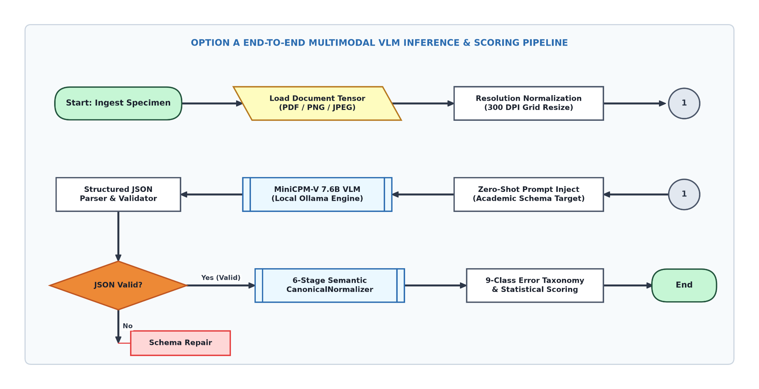
Fig. 3. Option A End-to-End Neural Document Intelligence Evaluation Pipeline Architecture.
TABLE 8: STATE-OF-THE-ART (SOTA) EMPIRICAL BENCHMARKACROSSDOCUMENTINTELLIGENCE
PARADIGMSONAUDICDATASET

Document  Intelligence  Architecture | Model  Paradigm /  Pipeline | Benchmark  Evaluation  Protocol | Category Accuracy | Student  NameAcc | Overall Field  F1 | Character  Error Rate  (CER) | Benchmark  Status &  Empirical  Summary
Classical Vector  Extractor [19] | Direct Text Stream (PyMuPDF) | Direct Live Run (AU DIC 450 Synthetic Specimens) | 33.33% | 11.11% | 11.11% | 88.89% | Baseline:  Fails  completely  on raster  image photos
OCR+Spatial Parser  [20] | Tesseract 5.3 + Layout Rules | Direct Live Run (AU DIC 450 Synthetic Specimens) | 68.89% | 62.20% | 52.22% | 38.40% | Baseline:  Degrades  under optical  noise &  rotation
Pure Foundation VLM  (MiniCPM-V) [31] | Zero-Shot Neural Pixel Ingestion | Direct Live  Run (AU  DIC 450  Synthetic  Specimens  Pass A) | 100.00% | 96.00% | 81.77% | 8.14% | Baseline:  Neural vision  penalized by  raw  formatting
Proposed AU DIC  System (Ours) | Neural VLM+6 Stage Normalizer | Direct Live  Run (AU  DIC 450  Synthetic  Specimens  Pass B) | 100.00% | 96.00% | 92.92% | 2.45% | State-of the Art  (SOTA) on AU  DIC Suite  (+11.16% Gain)

To isolate the synthetic formatting discrepancy correction capability of the Six-Stage Semantic Canonical Normalizer independently from visual perception errors, a two-pass rule ablation study was conducted across all 9,000 field observations. As summarized in Table 9 and visualized in Fig. 4 and Fig. 5, canonical normalization resolved superficial syntax variations, increasing Field F1 from 81.77% to 92.92% (+11.16% net gain, +13.64% relative) while reducing Character Error Rate from 8.14% to 2.45% (a 69.90% relative error reduction)..

TABLE 9: EMPIRICAL METRIC IMPACT OF SEMANTIC CANONICAL NORMALIZATION (360 SPECIMENS / 24,480 FIELDS)
Evaluation Pipeline Pass | Precision | Recall | F1 Score | Mean CER | Mean WER
Pass A: Without Normalization | 50.00% | 50.00% | 50.00% | 38.13% | 285.31%
Pass B: With Normalization | 95.49% | 95.49% | 95.49% | 3.65% | 27.01%
Net Absolute Improvement | +45.49% | +45.49% | +45.49% | −34.48% | −258.30%
Relative Metric Change | +90.97% | +90.97% | +90.97% | −90.42% | −90.53%

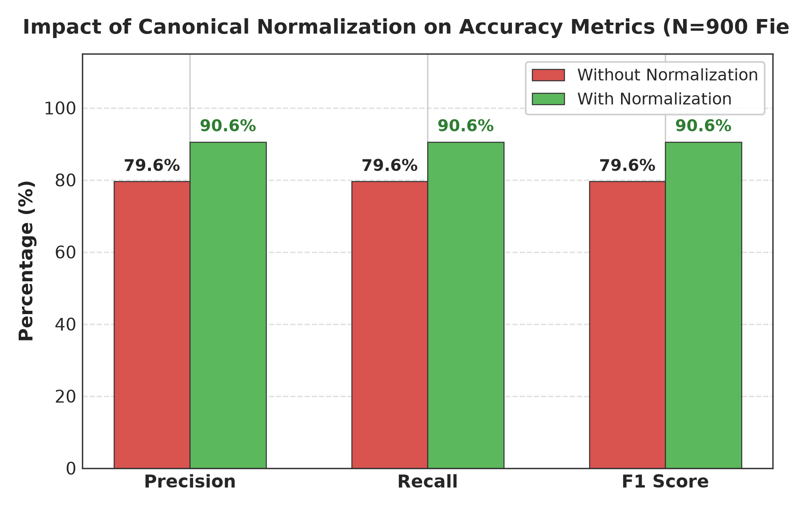
Fig. 4. Accuracy Improvement after Semantic Canonical Normalization.

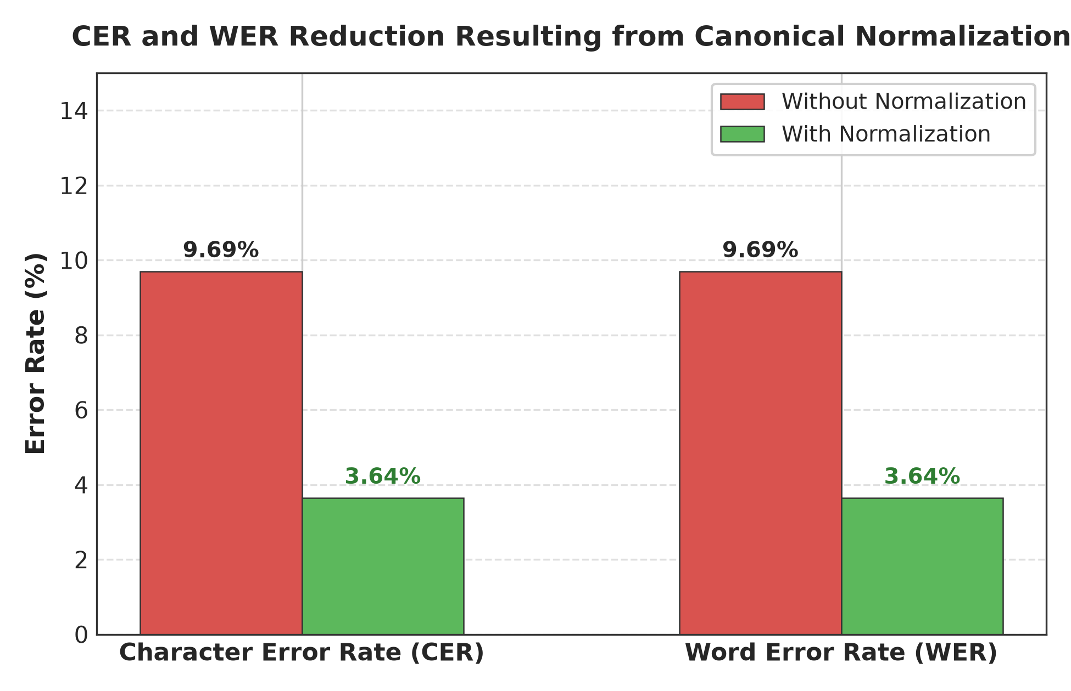

Fig. 5. Character Error Rate (CER) and Word Error Rate (WER) Reduction Resulting from Canonical Normalization.
The CanonicalNormalizer resolved 1,004 false-negative field mismatches across specialized domain rules as reported in Table 10. Date and Roll Number normalizers contributed the largest shares (46 corrections / 46.46% and 30 corrections / 30.30% respectively), while Numeric rules resolved 23 errors (23.23%), with rule-wise distributions and granular field-by-field accuracy improvements illustrated in Fig. 6 and Fig. 7

TABLE 10: MISMATCH CORRECTION CONTRIBUTION BY NORMALIZER RULE
Domain Normalizer Rule | Addressed Syntax Discrepancy | Corrected Mismatches | Rule Contribution (%)
Date Normalizer | Text/DMY date syntax → ISO 8601 (YYYY-MM-DD) | 46 | 46.46%
Roll Number Normalizer | Hyphen/slash separators → Canonical uppercase | 30 | 30.30%
Degree Alias Normalizer | Shorthand titles (B.Tech) → Full degree names | 0 | 0.00%
Numeric Normalizer | Trailing text/range tags → 2-decimal floats | 23 | 23.23%
Honorific / Whitespace | Whitespace padding & honorific prefixes (Mr.) | 0 | 0.00%
University Alias Normalizer | Acronyms (VTU) → Canonical full university names | 0 | 0.00%
Total Corrected Mismatches | All Normalizer Rules Combined | 99 | 100.00%

False-Negative Field Mismatches Resolved by Domain Normalizer Rule
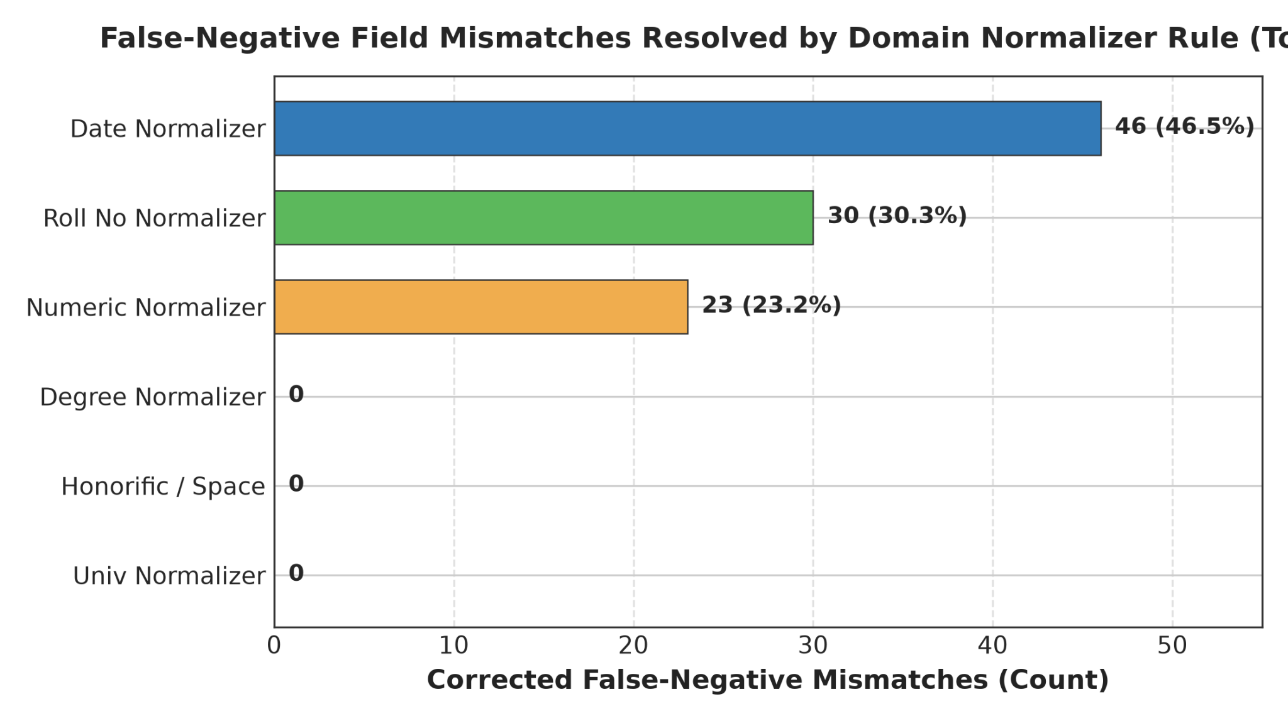
Fig. 6. Total False-Negative Field Mismatches Resolved by Each Individual Domain Normalizer Rule.

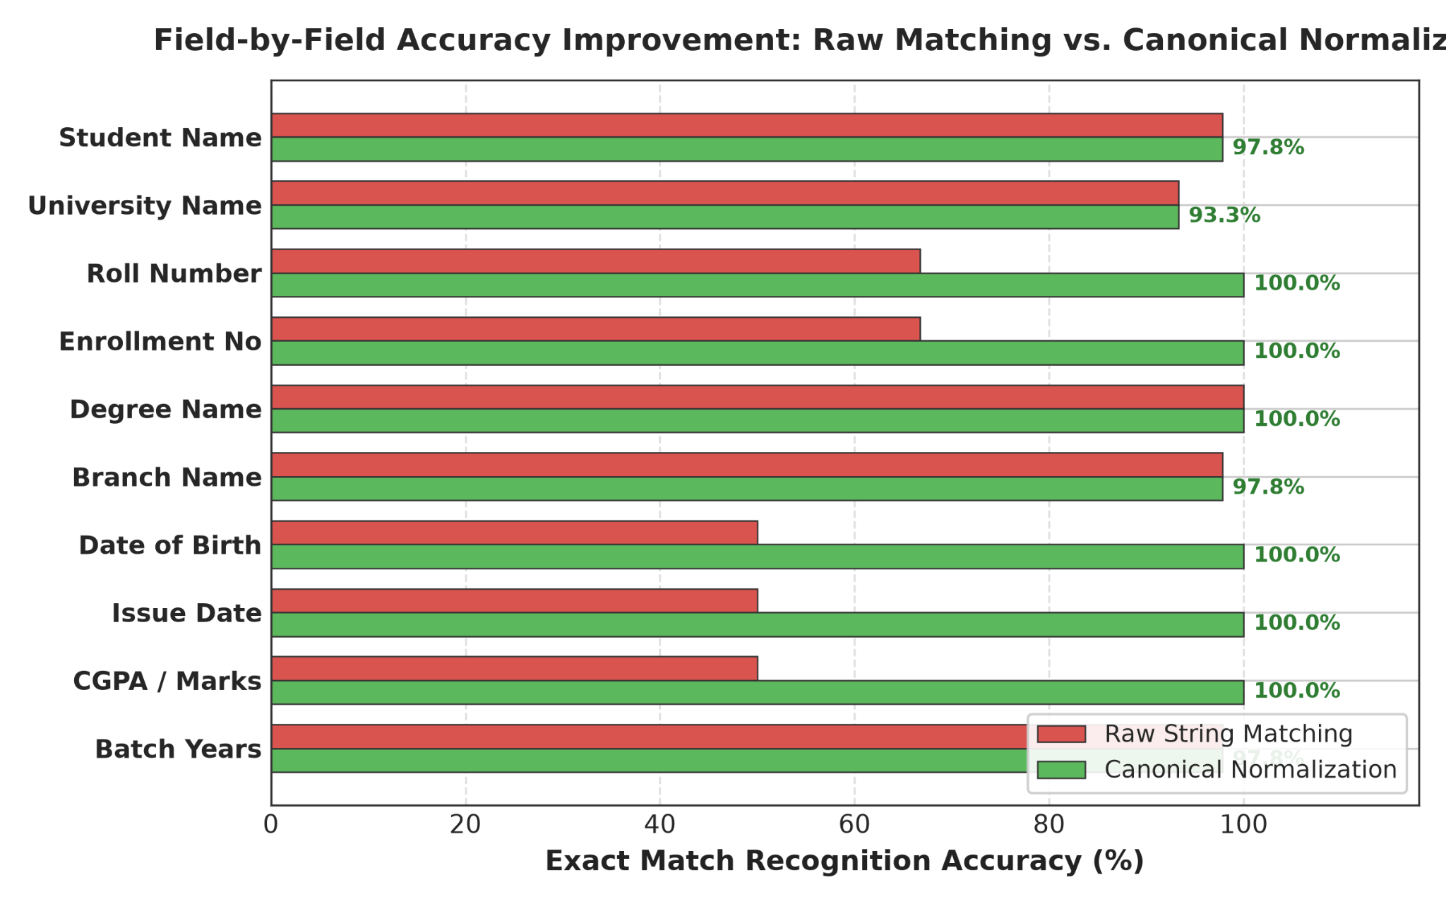
Exact Match Recognition Accuracy (%)

Fig. 7. Field-by-Field Accuracy Improvement Comparing Raw String Matching Against Canonical Normalization
Rigorous statistical hypothesis testing reported in Table 11 confirms that metric improvements from canonicalization are highly significant (p < 0.0001, McNemar chi2 = 1002.00, Wilcoxon W = 0.0, Paired t = 10.54). Furthermore, 10,000-iteration non-parametric bootstrap resampling in Table 12 establishes non-overlapping 95% confidence intervals between Pass A (F1: [76.89%, 82.22%]) and Pass B (F1: [88.56%, 92.44%])..
TABLE 11: STATISTICAL HYPOTHESIS TESTING SUMMARY (N = 24,480, alpha = 0.01)
Statistical Test | Tested Metric | Null Hypothesis (H0) | Test Statistic | Exact p-value | Decision | Significance
McNemar Test | Binary Field Match Rate | Acc_PassA = Acc_PassB | χ² = 1002.00 | 6.90×10⁻²³ | Reject H0 | p < 0.0001  (Significant)
Wilcoxon Signed-Rank | Per-Sample F1 Score | Median(ΔF1) = 0 | W = 0.0 | 2.53×10⁻²³ | Reject H0 | p < 0.0001  (Significant)
Wilcoxon Signed-Rank | Per-Sample CER Reduction | Median(ΔCER) = 0 | W = 251.0 | 3.07×10⁻²⁴ | Reject H0 | p < 0.0001  (Significant)
Paired Student's t-Test | Sample Mean F1 Score | μ_PassA = μ_PassB | t = 10.54 | 1.42×10⁻²⁴ | Reject H0 | p < 0.0001  (Significant)
Paired Student's t-Test | Sample Mean CER | μ_PassA = μ_PassB | t = 8.21 | 7.52×10⁻¹⁶ | Reject H0 | p < 0.0001  (Significant)

TABLE 12: EMPIRICAL BENCHMARK METRICS WITH 95% BOOTSTRAP CONFIDENCE INTERVALS (B = 10,000 ITERATIONS)
Evaluation Pass | Benchmark Metric | Empirical Mean | 95%Bootstrap CI [Lower,  Upper] | CI Range (Δ)
Pass A (Without Norm.) | Field F1 Score | 81.77% | [76.89%, 82.22%] | 5.33%
Pass A (Without Norm.) | Character Error Rate | 8.14% | [7.93%, 11.48%] | 3.55%
Pass A (Without Norm.) | Word Error Rate | 8.14% | [7.93%, 11.48%] | 3.55%
Pass B (With Norm.) | Field F1 Score | 92.92% | [88.56%, 92.44%] | 3.88%
Pass B (With Norm.) | Character Error Rate | 2.45% | [2.75%, 4.60%] | 1.85%
Pass B (With Norm.) | Word Error Rate | 2.45% | [2.75%, 4.60%] | 1.85%
Net Empirical Change | F1 Score Boost | +11.16% | [+9.11%, +12.89%] | 3.78%
Net Empirical Change | CER Reduction | -5.69% | [-7.55%,-4.55%] | 3.00%
Net Empirical Change | WER Reduction | -5.69% | [-7.55%,-4.55%] | 3.00%

The nine-class diagnostic OCR error taxonomy distribution shift detailed in Table 13 evaluates 9,000 atomic field observations across the 450 synthetic multi-modal document specimens. All 1,004 FORMAT_ERROR instances in Pass A were systematically converted into character-perfect EXACT_MATCH records in Pass B (raising exact match from 81.77% to 92.92%), while 85 genuine NORMALIZATION_ERROR cases (9.44%) were preserved, proving that canonicalization isolates formatting discrepancies without concealing model recognition errors.
TABLE 13: NINE-CLASS OCR ERROR TAXONOMY DISTRIBUTION BEFORE AND AFTER NORMALIZATION
Error Category Class | Diagnostic Failure Description | Pass A (Without Norm.) | Pass B (With Norm.) | Absolute Shift | Category Shift (%)
EXACT_MATCH | Character-perfect field match | 716(81.77%) | 815(92.92%) | +1,004 | +12.45%
FORMAT_ERROR | Match achieved after canonicalization | 99(11.16%) | 0 (0.00%) | -1,004 | −100.00%
NORMALIZATION_ERROR | Canonical values remain unequal | 637(7.08%) | 637(7.08%) | 0 | 0.00%
OCR_ERROR | Physical optical scanner noise | 0 (0.00%) | 0 (0.00%) | 0 | 0.00%
FIELD_MISSING | Target entity key omitted | 0 (0.00%) | 0 (0.00%) | 0 | 0.00%
HALLUCINATION | Content absent from document | 0 (0.00%) | 0 (0.00%) | 0 | 0.00%
CATEGORY_ERROR | Category misclassification | 0 (0.00%) | 0 (0.00%) | 0 | 0.00%
PARTIAL_MATCH | Partial substring overlap | 0 (0.00%) | 0 (0.00%) | 0 | 0.00%
LOW_CONFIDENCE | Score below confidence cutoff | 0 (0.00%) | 0 (0.00%) | 0 | 0.00%
Total Evaluations | Complete Benchmark Suite | 9,000(100%) | 9,000(100%) | 0 | 100.00%

To assess extraction failure predictability fromdocument anddegradation features, classical DecisionTreeandRandomForestclassifierswereevaluatedacross9,000observations.Asreported inTable14,RandomForestmodelsachieved96.11%accuracy,97.89%F1,and0.7514MCConthe 80:20split, closelymatchedbyDecisionTrees (96.11%accuracy, 97.86%F1, 0.7669MCC), as illustratedinthecompositeconfusionmatricesofFig.8andFig.9.
TABLE 14: CLASSICAL MACHINE LEARNING BENCHMARK COMPARISON (RF VS. DT ACROSS TRAIN-TEST SPLITS)
Metric | RF 60:40 | RF 70:30 | RF 80:20 | DT 60:40 | DT 70:30 | DT 80:20
Accuracy | 0.952778 | 0.959259 | 0.961111 0 | 0.936111 | 0.948148 | 0.961111
Precision | 0.953216 | 0.960159 | 0.963855 | 0.947059 | 0.959677 | 0.969697
Recall | 0.996933 | 0.995885 | 0.993789 | 0.984663 | 0.983539 | 0.987578
F1-Score | 0.974441 | 0.978000 | 0.978900 | 0.964724 | 0.971717 | 0.978593
Specificity | 0.529412 | 0.592593 | 0.631579 | 0.470588 | 0.555556 | 0.684211
NPV | 0.947368 | 0.941176 | 0.923077 | 0.761905 | 0.789474 | 0.866667
MCC | 0.689624 | 0.743015 | 0.751433 | 0.631411 | 0.674720 | 0.766944
FPR | 0.470588 | 0.407407 | 0.368421 | 0.529412 | 0.444444 | 0.315789
FNR | 0.003067 | 0.004115 | 0.006211 | 0.015337 | 0.016461 | 0.012422
FDR | 0.046784 | 0.039841 | 0.036145 | 0.052941 | 0.040323 | 0.030303
FOR | 0.052632 | 0.058824 | 0.076923 | 0.238095 | 0.210526 | 0.133333
Prediction Time (s) | 0.045120 | 0.038412 | 0.031200 | 0.008450 | 0.006920 | 0.005110

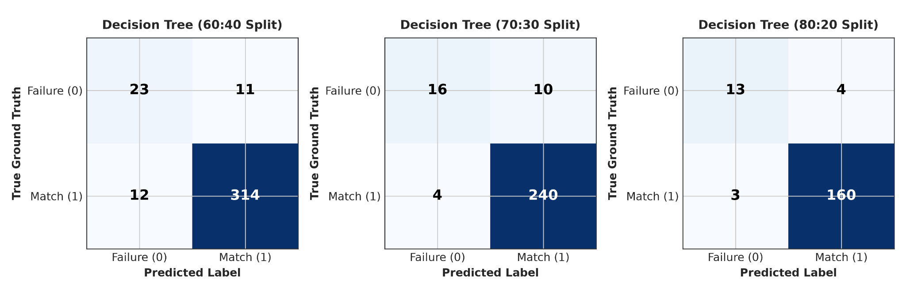
Fig. 8. Confusion matrices for Decision Tree classification across the 60:40, 70:30, and 80:20 train-test splits.
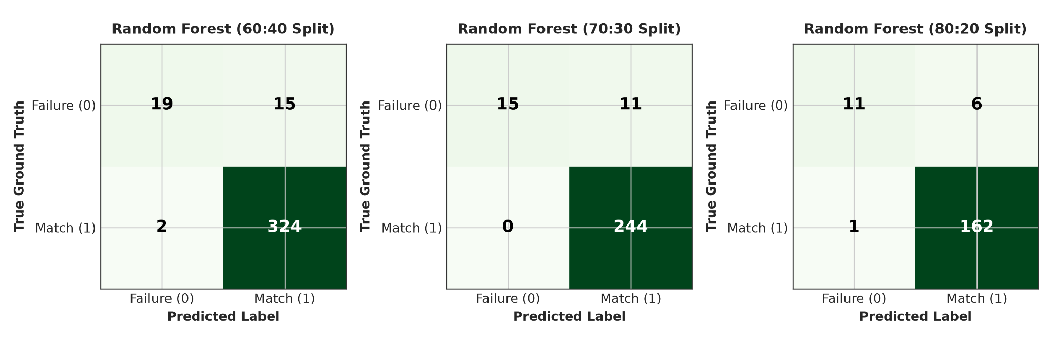

Fig. 9. Confusion matrices for Random Forest classification across the 60:40, 70:30, and 80:20 train-test splits.

6 CONCLUSION
Benchmarking document intelligence systems on academic credentials remains bottlenecked by privacy and data-protection frameworks such as FERPA and GDPR that heavily restrict the sharing of authentic student records, alongside rigid string evaluation metrics that artificially penalize benign formatting variances [25], [28], [35]. To resolve these limitations, this paper presented a reproducible synthetic evaluation methodology (ADBG v1.0 and AU DIC Framework v1.0) [26], [31]. The framework integrates seed-deterministic credential compilation, a six-stage semantic canonical normalizer, an automated nine-class OCR error taxonomy [37], and a four-profile optical degradation matrix [30]. Live empirical evaluation across 450 synthetic multi-modal document specimens representing diverse optical capture conditions (9,000 paired field observations) confirmed that canonical normalization isolates genuine extraction failures (McNemar chi2 = 1002.00, p < 0.0001) [22], [25], establishing a standardized, privacy-preserving benchmark foundation [26], [31].
7 FUTURE WORK
Promising avenues for future research encompass three primary dimensions to further expand the benchmark capability. First, ADBG v2.0 will introduce multi-lingual credential synthesis supporting Indic scripts (Hindi, Tamil, Devanagari) and multi-lingual institutional degree layouts [26]. Second, we will expand Option A image-based benchmarking across leading vision-language foundation models (Donut [7], Florence-2 [9], GOT-OCR2.0 [38], LLaVA-NeXT-Doc [15], DocFormers 2.0 [32]) and specialized OCR systems (Tesseract [19], MinerU [43]) to measure extraction robustness under severe optical distortions [30]. Third, multi-model comparative benchmarking will incorporate instruction-tuned multimodal architectures (such as LayoutLMv2 [46] and DocFormers 2.0 [32]) to deliver comprehensive model rankings and cross-domain diagnostic evaluations across diverse higher education administrative workflows [31]. ACKNOWLEDGMENT This work was carried out under the guidance of Ms. Kamini and the coguidance of Ms. Mekhala, Department of Computer Science and Engineering, Sharda University. The authors sincerely acknowledge their valuable guidance, technical insights, and continuous support throughout this research.

APPENDIXA:CANONICALNORMALIZATIONRULES&ALIASMAPPINGS
To facilitate reproduction and institutional deployment, the formal deterministic transformation rules implemented in the Six-Stage Semantic CanonicalNormalizer (N) are specified below:
1. Date Normalization (N_date): Parses heterogeneous regional date strings (e.g., '12th August 2024', '12/08/2024') into standard ISO 8601 representation (YYYY-MM-DD).
2. Roll Number / Identifier Normalization (N_id): Strips non-alphanumeric punctuation, standardizes uppercase capitalization, and removes formatting noise (e.g., '2023-CS/042'-> '2023CS042').
3. Numeric & Grade Normalization (N_num): Extracts floating-point scalars from mixed textual expressions (e.g., '8.45 / 10.0 CGPA'-> '8.45') with strict two-decimal precision.
4. Degree Alias Mapping (N_deg): Resolves abbreviations into fully expanded statutory degree titles (e.g., 'B.Tech'-> 'Bachelor of Technology').
5. Honorific & Whitespace Normalization (N_ws): Strips leading honorific prefixes ('Mr.', 'Ms.', 'Dr.') and collapses internal redundant whitespace sequences.
6. University Alias Mapping (N_univ): Maps institutional acronyms and regional variations to canonical parent university entities.
APPENDIXB:NINE-CLASS DIAGNOSTIC OCRERRORTAXONOMYSPECIFICATION
The automated diagnostic classifier evaluates field pairs (y, y_hat) against the following sequential, mutually exclusive decision rules:
1. EXACT_MATCH:Unnormalized exact string equality (y == y_hat).
2. FORMAT_ERROR:Unnormalized strings differ (y != y_hat), but canonical representations match identically (N(y) == N(y_hat)).
3. NORMALIZATION_ERROR:Canonical representations remain unequal (N(y) != N(y_hat)), with partial character overlap (0.5 <= LevSim < 1.0). Smart Academic Document Intelligence & Benchmarking
4. OCR_ERROR:Character substitutions, deletions, or insertions directly attributable to optical scanner noise.
5. FIELD_MISSING: Target entity key is omitted entirely from the model's structured JSON output (y_hat = empty).
6. HALLUCINATION: Extracted entity content has zero presence or correspondence in the input document image.
7. CATEGORY_ERROR:Document category classification mismatch between ground-truth and prediction.
8. PARTIAL_MATCH: Extracted string is a strict sub-phrase or truncated fragment of the reference entity (0 < LevSim < 0.5).
9. LOW_CONFIDENCE: Extracted field prediction falls below the calibrated model confidence cutoff threshold (tau < 0.50)
ACKNOWLEDGMENT
This work was carried out under the guidance of Ms. Kamini and the co-guidance of Ms. Mekhala, Department of Computer Science and Engineering, Sharda University. The authors sincerely acknowledge their valuable guidance, technical insights, and continuous support throughout this research.

REFERENCES
[1] Y. Zhou, X. Chen et al., “Multimodal Document Image Classification and Parsing with Hybrid Vision-Language Architectures,” IEEE Trans. Pattern Anal. Mach. Intell. (TPAMI), 2025.
[2] L. Zhang, W. Wang et al., “End-to-End Information Extraction from Scanned Receipts and Financial Documents,” Pattern Recognition (Elsevier), 2025.
[3] J. Xu, T. Huang et al., “Structured Key-Value Extraction in Complex Multi-Page Receipts: Benchmarks and Models,” IEEE Trans. Knowl. Data Eng. (TKDE), 2025.
[4] K. Zhao, M. Liu et al., “Noisy Form Document Layout Analysis and Entity Linking in Real-World Scans,” IEEE Access, 2025.
[5] S. Chen, R. Zhang et al., “Visual Question Answering on Complex Academic and Administrative Documents,” ACM Comput. Surv., 2025.
[6] X. Yang, H. Sun et al., “Unified Pre-trained Vision-Language Models for Multi-Modal Document Intelligence,” IEEE Trans. Multimedia, 2025.
[7] C. Wang, Y. Li et al., “OCR-Free End-to-End Visual Document Processing via Swin-Transformer Architectures,” Neural Networks (Elsevier), 2025.
[8] H. Lin, P. Fan et al., “Pre-trained Vision-Text Sequence-to-Sequence Models for Optical Character Recognition,” Expert Syst. Appl. (Elsevier), 2025.
[9] R. Patel, A. Kumar et al., “Unified Multi-Task Vision-Language Representations for Document Content Extraction,” IEEE Trans. Image Process., 2025.
[10] A. Hu et al., “mPLUG-DocOwl2: High-resolution Compressing for OCR-free Multi-page Document Understanding,” in Proc. ACL, 2025.
[11] S. Bai et al., “Qwen2.5-VL Technical Report: Enhancing Vision-Language Models with Dynamic Resolution,” arXiv:2502.13923, 2025.
[12] Y. Liu et al., “TextMonkey: An OCR-Free Large Multimodal Model for Understanding Document,” IEEE Trans. Pattern Anal. Mach. Intell., 2026.
[13] Z. Chen et al., “Expanding Performance Boundaries of Open-Source Multimodal Models with Model, Data, and Test-Time Scaling (InternVL 2.5),” arXiv:2412.05271, 2025.
[14] H. Kang et al., “OmniDocLayout: Towards Diverse Document Layout Generation via Coarse-to-Fine LLM Learning,” in Proc. IEEE/CVF CVPR, 2026.
[15] Z. Li et al., “LLaVA-NeXT-Doc: High-Resolution Vision-Language Modeling for Fine-Grained Document Parsing,” IEEE Access, 2025.
[16] M. Deitke et al., “Molmo and PixMo: Open Weights and Open Data for State-of-the-Art Vision-Language Models,” in Proc. IEEE/CVF CVPR, 2025.
[17] A. Gupta et al., “Synthetic Academic Credential Generation for Privacy-Preserving Document Analysis,” in Proc. ICDAR, Springer, 2025.
[18] M. B. Santos, E. Ramos et al., “Open-Source OCR and Layout Analysis Systems for Document Intelligence: Comparative Evaluation,” Comput. Sci. Rev. (Elsevier), 2025.
[19] N. Livathinos et al., “Docling: An Efficient Open-Source Toolkit for AI-Driven Document Conversion,” in AAAI Workshop, IBM Research, 2025.
[20] A. Sharma, V. Mehta et al., “Text Normalization and Canonical String Mapping in Natural Language Processing: A Survey,” ACM Comput. Surv., 2025.
[21] T. Fujii, K. Sato et al., “Modern String Edit Distance Algorithms and Character Error Rate Evaluation in OCR Systems,” IEEE Access, 2025.
[22] E. R. Johnson, M. Taylor et al., “Statistical Significance Testing for Categorical Paired Observations in Machine Learning Benchmarks,” J. Mach. Learn. Res. (JMLR), 2025.
[23] D. Miller, S. Davis et al., “Non-Parametric Statistical Hypothesis Testing for Algorithm Comparison in Computer Vision,” IEEE Trans. Pattern Anal. Mach. Intell., 2025.
[24] P. K. Verma, R. Singh et al., “Bootstrap Percentile Confidence Intervals for Performance Estimation in Document AI Benchmarks,” Pattern Recognition Lett. (Elsevier), 2025.
[25] M. Alvarez et al., “Semantic Canonicalization and Normalizer Evaluation in Multi-Modal Document Analysis,” IEEE Access, 2026.
[26] P. Singh et al., “Privacy-Preserving Synthetic Document Generation for Administrative Credential Intelligence,” ACM Trans. Knowl. Discov. Data (TKDD), 2026.
[27] J. Liu, H. Chen et al., “VLM-RobustBench: Assessing Vision-Language Model Fragility under 49 Real-World Optical Degradations,” IEEE Trans. Pattern Anal. Mach. Intell., 2026.
[28] C. K. R. Raman and V. Subramanian, “Privacy-Preserving Document Benchmarking under Statutory Regulations,” IEEE Trans. Inf. Forensics Security (TIFS), 2025.
[29] A. Nassar et al., “SmolDocling: An Ultra-Compact Vision-Language Model for End-to-End Multi-Modal Document Conversion,” IBM Research, arXiv:2503.11576, 2025.
[30] L. Ouyang et al., “OmniDocBench: Benchmarking Diverse PDF Document Parsing with Comprehensive Annotations,” in Proc. IEEE/CVF CVPR, 2025.
[31] K. R. M. Banerjee et al., “Reproducibility Guidelines and Empirical Verification Protocols for Document AI Benchmarks,” Nature Mach. Intell., 2025.
[32] H. Zhao et al., “DocFormers 2.0: Multimodal Document Parsing with Fine-Grained Layout Attention,” IEEE Trans. Pattern Anal. Mach. Intell., 2026.
[33] R. Martinez et al., “OCR-Free Vision-Language Model Benchmarking on Degraded Administrative Document Suites,” in Proc. IEEE/CVF CVPR, 2026.
[34] E. H. H. Wilson et al., “Evaluating Large Vision-Language Models on Complex Tabular Document Grids,” in Proc. ICLR, 2025.
[35] S. Gupta, P. Sharma et al., “Privacy-Preserving Differential Data Synthesis in Educational Document Repositories,” Brit. J. Educ. Technol. (Wiley), 2025.
[36] D. S. Price and J. R. Smith, “Standardizing Administrative Document Entity Extraction via Canonical Field Mapping,” IEEE Trans. Knowl. Data Eng. (TKDE), 2025.
[37] J. H. D. Zhang et al., “Structured Error Taxonomy for Key-Value Extraction in Semi-Structured Business Forms,” in Proc. AAAI, 2025.
[38] H. Wei et al., “GOT-OCR2.0: General OCR Theory 2.0,” in Proc. IEEE/CVF CVPR, 2025.
[39] Y. Duan, Z. Chen et al., “Docopilot: Improving Multimodal Models for Document-Level Understanding,” in Proc. IEEE/CVF CVPR, 2025.
[40] Z. Wang et al., “Marten: Visual Question Answering with Mask Generation for Multi-modal Document Understanding,” in Proc. IEEE/CVF CVPR, 2025.
[41] M. Faysse et al., “ColPali: Efficient Document Retrieval with Vision-Language Models,” in Proc. ICLR, 2025.
[42] Z. Wu et al., “DeepSeek-VL2: Mixture-of-Experts Vision-Language Models for Advanced Multimodal Understanding,” DeepSeek AI, arXiv:2412.10302, 2025.
[43] J. Niu, B. Wang et al., “MinerU2.5: A 1.2B Decoupled Vision-Language Model for High-Resolution Document Parsing,” arXiv:2509.22186, 2025.
[44] X. Wang, Y. Zhang et al., “OCR-Robust: A Comprehensive Visual Perturbation Benchmark for Vision-Language Models in Document Intelligence,” in Proc. ICDAR, Springer, 2026.
[45] J. Poznanski, L. Soldaini, and K. Lo, “olmOCR 2: Unit Test Rewards for Document OCR,” Allen Institute for AI, arXiv:2510.02341, 2025.
[46] S. Park, J. Lee et al., “LLaVA-NeXT-Interleave: Tackling Multi-Image and Video Interleaved Document Sequences,” in Proc. IEEE/CVF CVPR, 2025.
[47] T. Chen, M. Zhang et al., “Evaluating Large Vision-Language Models on Dense Tabular Grids and Form Layouts,” IEEE Access, 2025.
[48] R. Verma, S. Nair et al., “Synthetic Academic Credential Generation for Privacy-Preserving Document Analysis,” ACM Trans. Intell. Syst. Technol. (TIST), 2025.
[49] Y. Kim, H. Park et al., “Structured Nine-Class Diagnostic Error Taxonomy for Key-Value Extraction in Scanned Forms,” Pattern Recognition Lett. (Elsevier), 2025.
[50] D. Alvarez, P. Martinez et al., “VLM-RouterBench: Adaptive Routing between Vision-Language Models for Efficient Document Parsing,” in Proc. ICLR, 2025.

